A Report on

**Mobile Phone Detector**

for

**Mini Project 1-a (REV- 2019 ‘C’ Scheme) of Second Year (SE Sem-III)**

in

**Electronics & Telecommunication Engineering**

by

1. Riddhesh Veling
2. Shreyash Tiwari
3. Purva Shete
4. Mohd Aman

Under the guidance of

**Ms. Jovita Serrao**



**UNIVERSITY OF MUMBAI**

**AY 2020-2021**

College

College Logo

**St Francis Institute of Technology**

**CERTIFICATE**

This is to certify that the project entitled **Project Title** is a bonafide work of

1. Riddhesh Veling
2. Shreyash Tiwari
3. Purva Shete
4. Mohd Aman

submitted to the University of Mumbai in partial fulfillment of the requirement for the award of Mini **Project 1-a (REV- 2019 ‘C’ Scheme) of Second Year, (SE Sem-III)** in **Electronics & Telecommunication Engineering** as laid down by **University of Mumbai** during academic year **2022-23**

(_____________________) (_____________________)

**Examiner/Reviewer-1 Examiner/ Reviewer -2**

**Name of Guide**

**Guide Head of Department Principal**

**INDEX**

**Sr. No. Name of Topic Page Number**

|  |
| --- |
| Abbreviation ………………………………………………. i  List of Figures ……………………………………………… ii  List of Tables ………………………………………………. iii  List of Graphs ………………………………………………. iv  **1. INTRODUCTION**  1.1 Need ………………………………………………………… 1  1.2 Definition ………………………………………………………… 1  **2. PROBLEM STATEMENT**  ..........................................................  **1**  **3. Mini Project DESIGN (PRINCIPLE AND WORKING)**  3.1 Block Diagram ……………………………………………… 2  3.2 Block Diagram Description…………………………………… 2  3.3 Circuit diagram and working………………………………… 3  **4. COMPONENTS/TOOL TO BE USED**  4.1 Components (with features related to project ………………… 4  4.2 Software ……………………………………………………. 5  **5. PROPOSED EXECUTIONS STEPS**  5.1 Implemented Steps for PCB …………………………………... 6  5.2 PCB layout and soldering, Etching  (Actual photos of project from front and back view) ...………… 7  **6. Troubleshooting**  6.1 Problems/Faults in project ……………………………………. 11  6.2 Steps to solve problems/faults in project ……………………. 11  **REFERENCES ……………………………………………………………… 11**  **Appendix:** Data sheets of components |

**MOBILE PHONE DETECTOR**

1. **INTRODUCTION**

The most common electronic equipment used now-a-days is Cell Phone or Mobile Phone. With advancement in communication technology, the requirement of cell phones has increased dramatically**.**

* 1. NEED:

1.This circuit can be used at examination halls, meetings to detect presence of mobile phones and prevent the use of cell phones.

2. It can be used for detecting mobile phones used for spying and unauthorized transmission of audio and video.

* 1. DEFINITION:

As long as mobile network is there in out mobile phone they wouldn’t stop communicating with the nearest cell (network station to tower) but when we receive a call, try to call for someone or connect to the internet or mobile phone our mobile receives a higher frequency signal from the previous one that’s when we say our mobile phone is in active mode.

Mobile phone detectors are devices that can detect active mobile phone around them by using antenna-based detection system. As stated earlier when mobile phone is active there exist a radio frequency signal transmitted and receive by trans receiver and the mobile, thus mobile phone detector are designed to detect this kind of signal by their antenna and use it as an input and then give us an output e.g., buzzer, LED etc.

1. **PROBLEM STATEMENT:**

Unauthorized mobile phone usage in both public and private places has become a problem that may be difficult to solve. The rapid proliferation of cell phones at the beginning of the 21st century eventually raised problems such as invading privacy, egregious academic cheating and perfect for stealing data. The only way of ensuring that a cellular phone is not a secure area is to have an accurate method for sniffing (detecting) them.

A cell phone typically transmits and receives signals in the frequency range of 0.9 to 3GHz. This circuit is used to detect the presence of an activated cell phone by detecting these signals.

1. **MINI PROJECT DESIGN** (Principle and working)
   1. BLOCK DIAGRAM

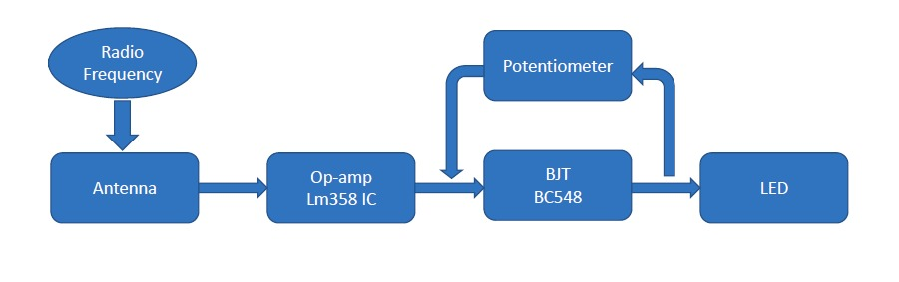

Fig 3.1.1

* 1. BLOCK DIAGRAM DESCRIPTION:

The RF signal emitted from the mobile phones is detected by the Antenna.

The antenna then converts this signal into electrical signal which travels through the circuit.

The LM358 op-amp then amplifies the received signal.

BJT BC548 acts as a switch in the circuit.

The potentiometer controls the brightness and blinking of the LED.

3.3 CIRCUIT DIAGRAM AND WORKING:

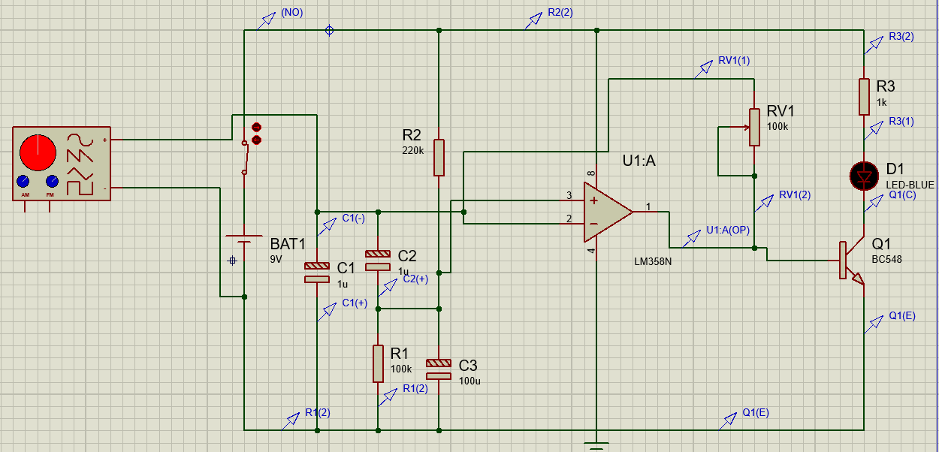

Fig 3.3.1

Device in Off state with no input frequency.

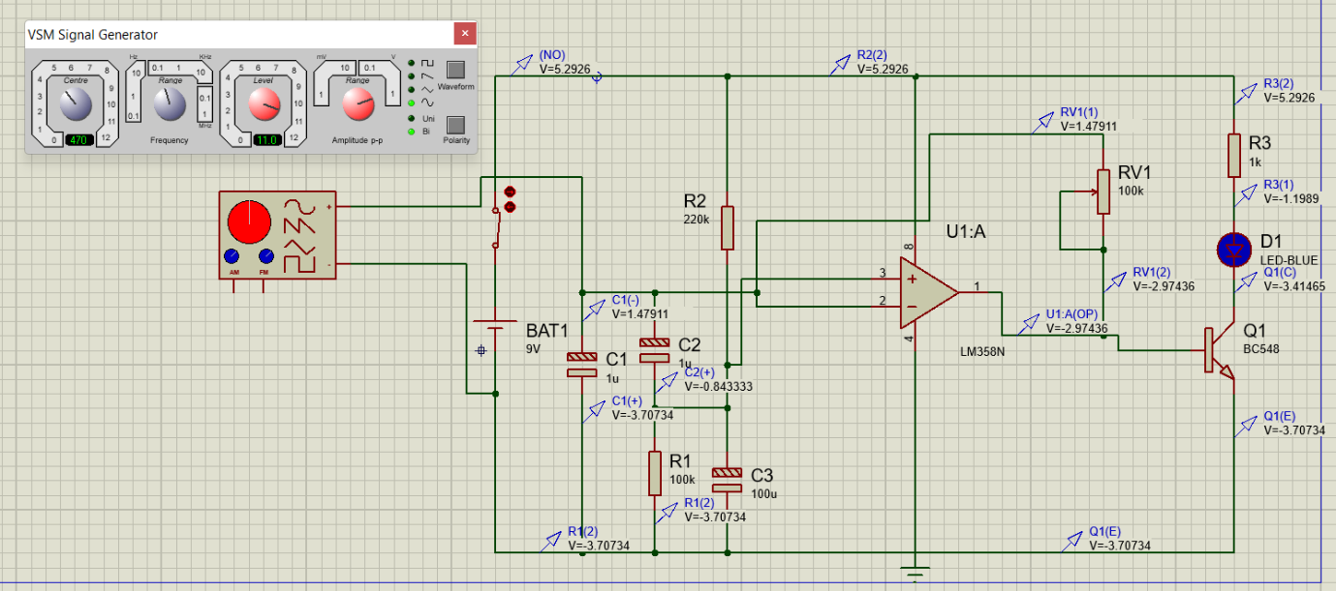

Fig 3.3.2

Device in working state with input frequency.

1. **COMPONENTS/TOOLS TO BE USED:**

4.1 COMPONENTS

1. **IC LM358**: The LM358 IC is a great, low power and easy to use dual channel op-amp IC. It is designed and introduced by national semiconductor. It consists of two internally frequency compensated, high gain, independent op-amps. This IC is designed for specially to operate from a single power supply over a wide range of voltages.

2. **T1 BC548:** It is a npn transistorworking here as a switch (CC configuration). In order to use the transistor as a switch, it must be driven into the saturation region with enough base current. And a transistor operates as a closed switch under the saturation region. As soon as a positive signal (in form of voltage and current) is removed across the base of the transistor, the flow of electric current between the collector and emitter becomes zero. And the transistor behaves like an open switch under the cut-off region. This simply implies if we apply signal (voltage/current) across the collector and emitter but not across the base, the transistor will not work. But a small signal across the base is enough to make it work.

3. **LED:** An LED is an electronic device that emits light when an electrical current is passed through it. Early LEDs produced only red light, but modern LEDs can produce several different colors, including red, green, and blue (RGB) light. Recent advances in LED technology have made it possible for LEDs to produce white light as well.

4. **Resistor**: A resistor is a passive two-terminal electrical component that implements electrical resistance as a circuit element. In electronic circuits, resistors are used to reduce current flow, adjust signal levels, to divide voltages, bias active elements, and terminate transmission lines, among other uses.

5. **Capacitor:** A capacitor is a device that stores electrical energy in an electric field. It is a passive electronic component with two terminals.

6. **Antenna:** It receives radiofrequency radiation and converts it into electric currents in an electric circuit connected to the antenna.

4.2 SOFTWARE: Proteus

The Proteus is a proprietary software tool suite used primarily for electronic design automation.

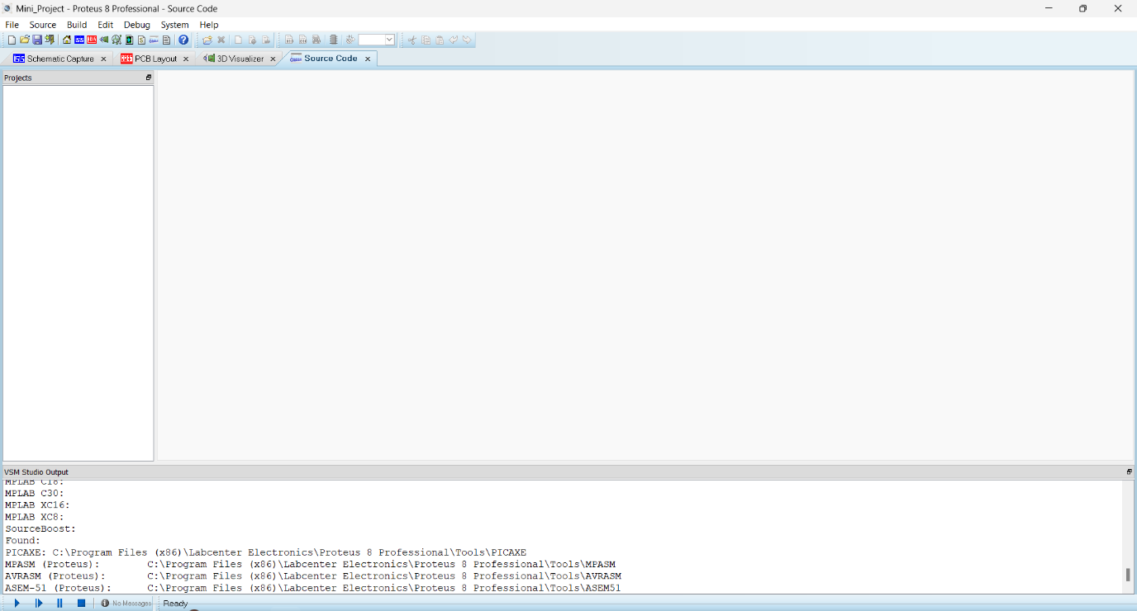

Fig. 4.2.1

The software is used mainly by electronic design engineers and technicians to create schematics and electronic prints for manufacturing printed circuit boards.

1. **PROPOSED EXECUTIONS STEPS**
   1. IMPLEMENTED STEPS FOR PCB:
2. The PCB layout file was first converted into PDF file for making it easy for the printing process.
3. The PCB print was then taken on a ‘glossy paper’.
4. This print on the glossy paper was placed on the one-sided PCB board and by using iron, the print was transferred on the PCB board.
5. The print was ironed on the board for about 15 minutes while applying very high pressure.
6. Once we get all the tracks of the circuit on PCB board, the board was then dipped into the Ferric Chloride solution.
7. Due to Ferric Chloride, the copper on the PCB board which is not covered under the tracks in the previous steps gets dissolved. Thus, leaving behind the circuit.
8. Now, holes are drilled into the circuit following the holes that are left in the PCB layout.
9. The components are then inserted form the opposite side of copper tracks.
10. The components are soldered neatly into the circuit.

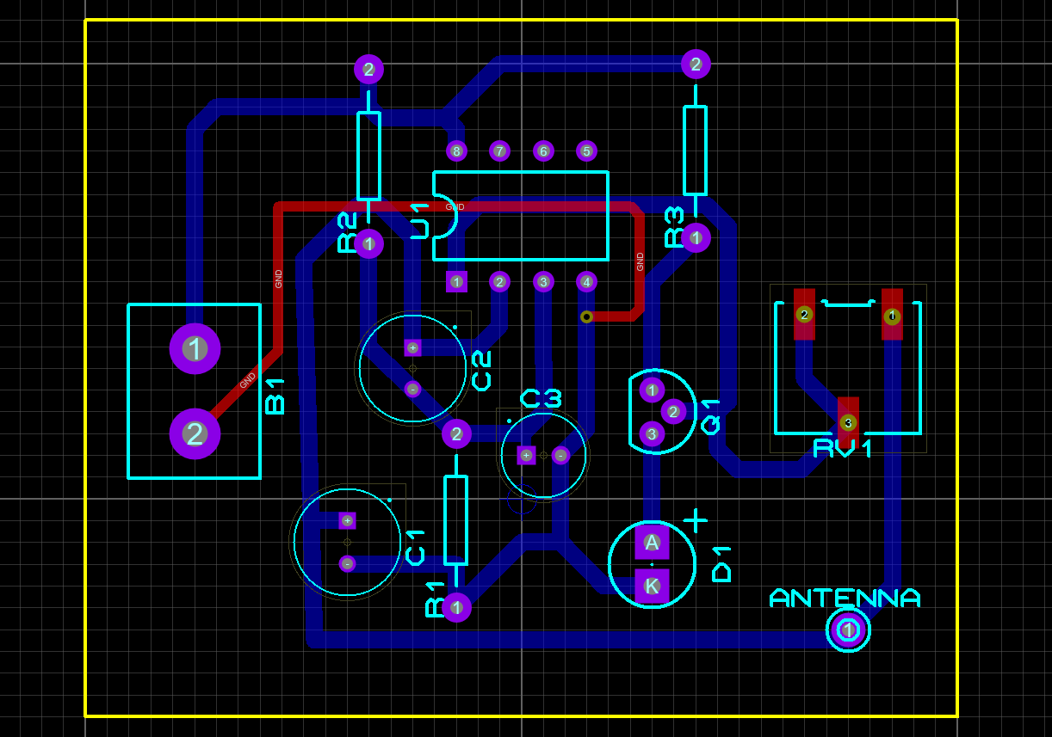5.2 PCB LAYOUT AND SOLDERING:

Fig. 5.2.1 PCB layout made using proteus

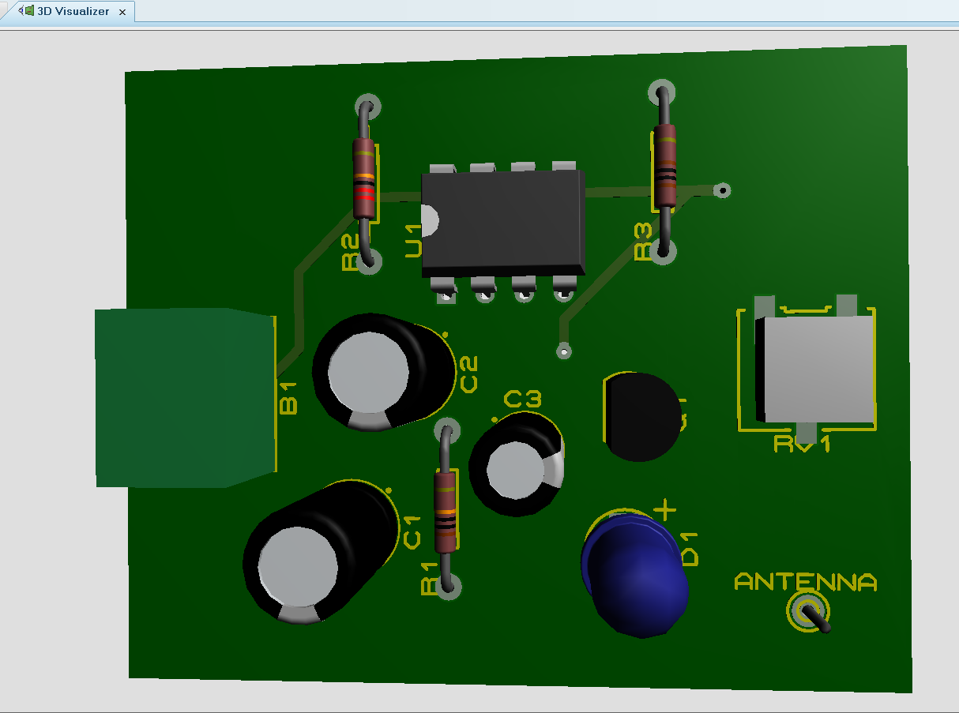

Fig. 5.2.2 Checking of PCB with help of 3D Visualizer

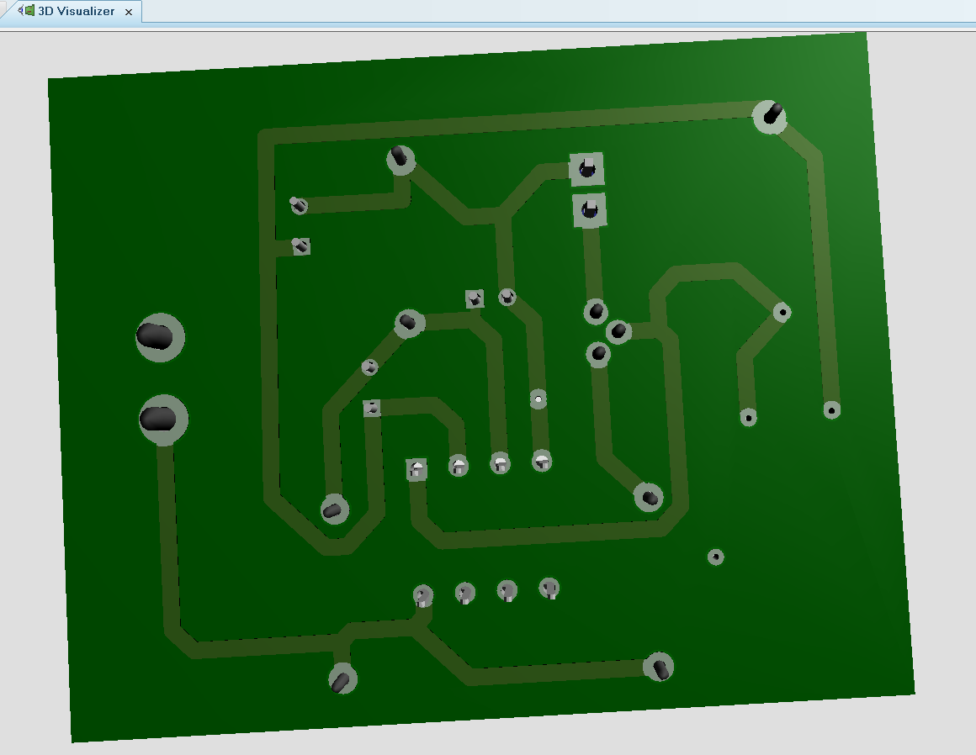

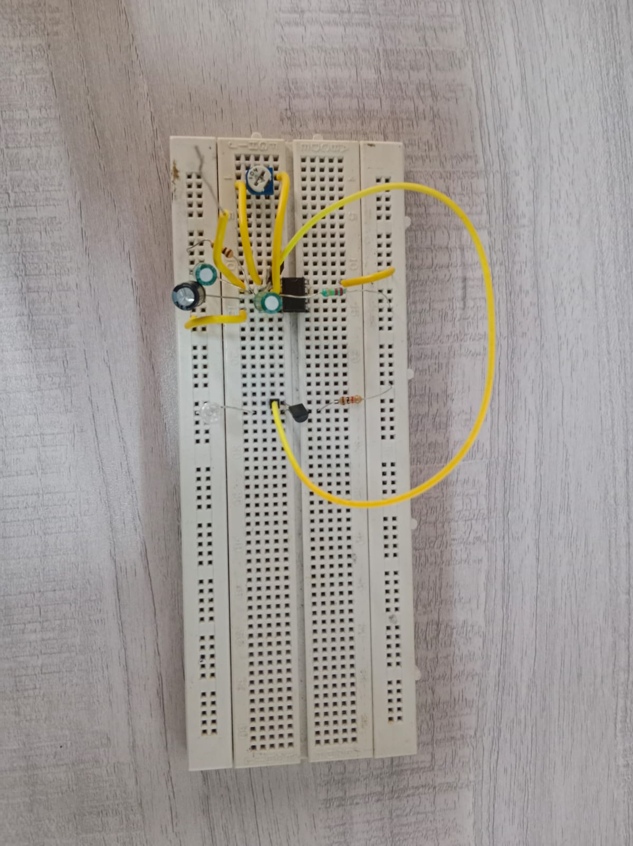

Fig. 5.2.3 How backside of PCB would look using 3D Visualizer

Fig 5.2.4 Circuit is connected on breadboard

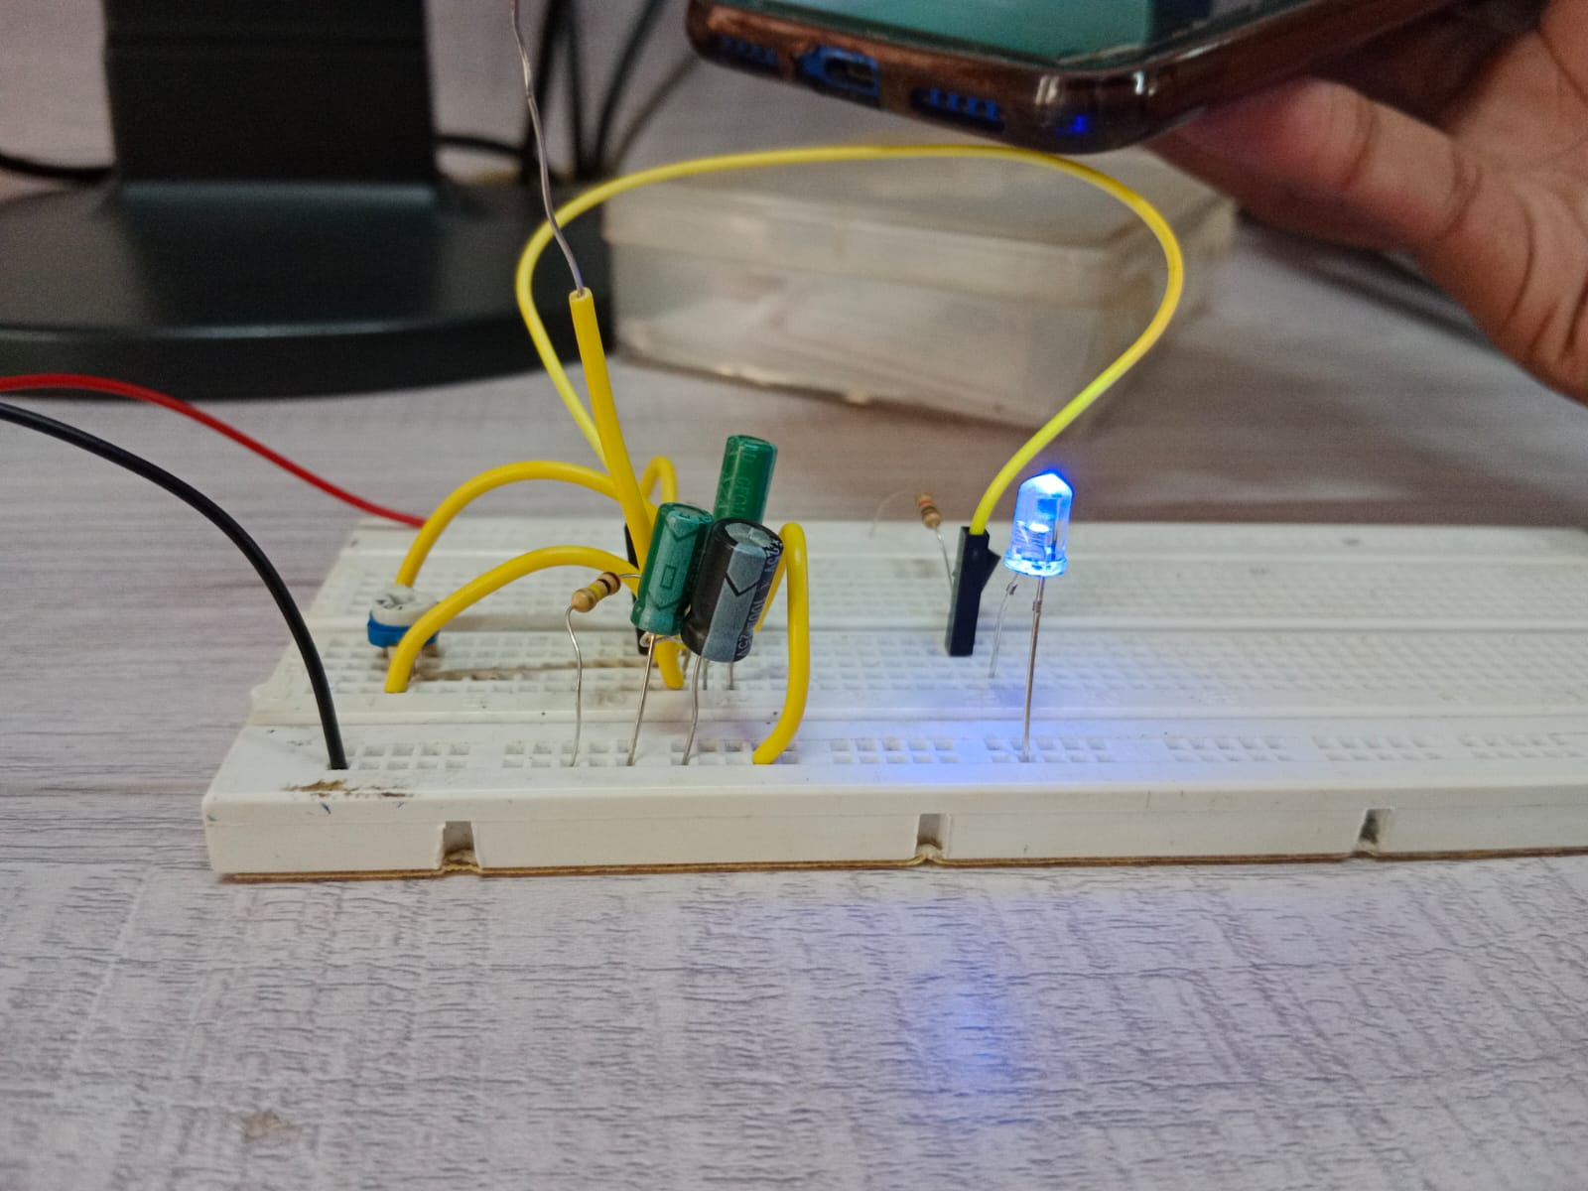

Fig 5.2.5 The LED glows when phone is detected

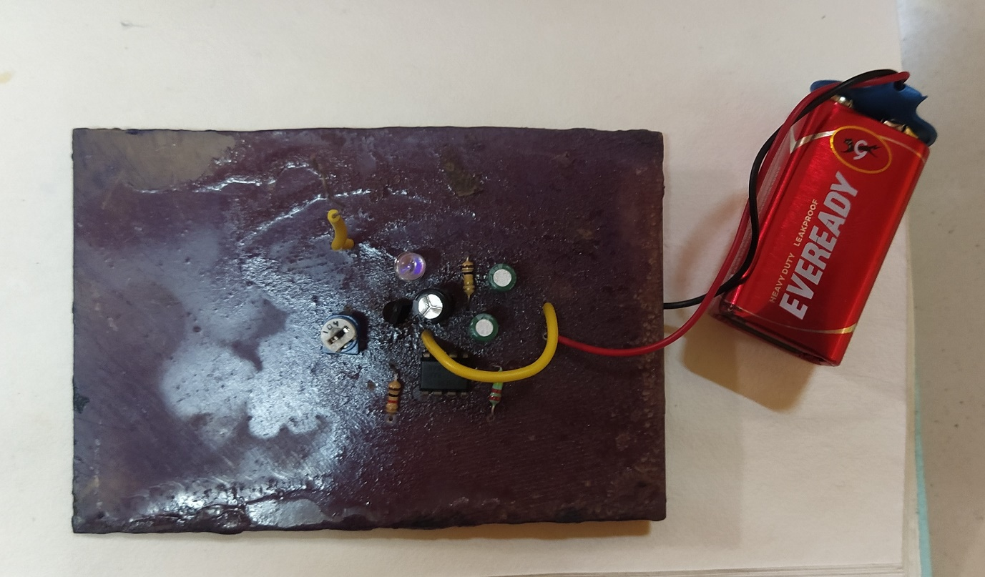

Fig 5.2.6 Circuit on PCB board

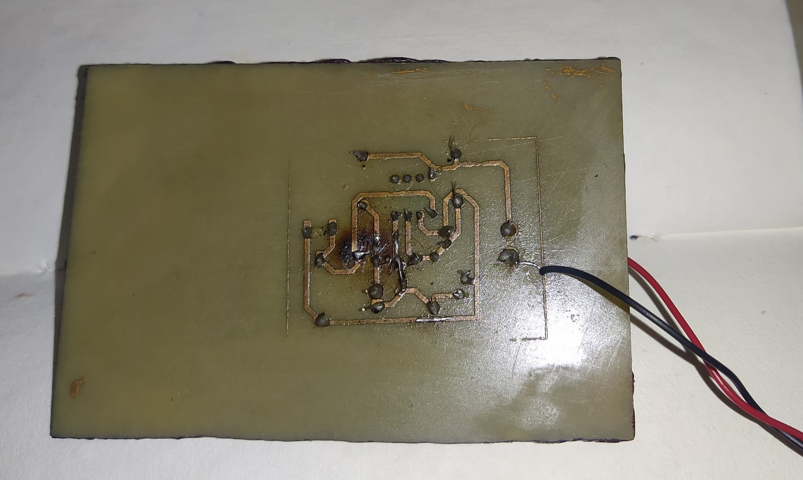

Fig 5.2.7 Soldering on PCB

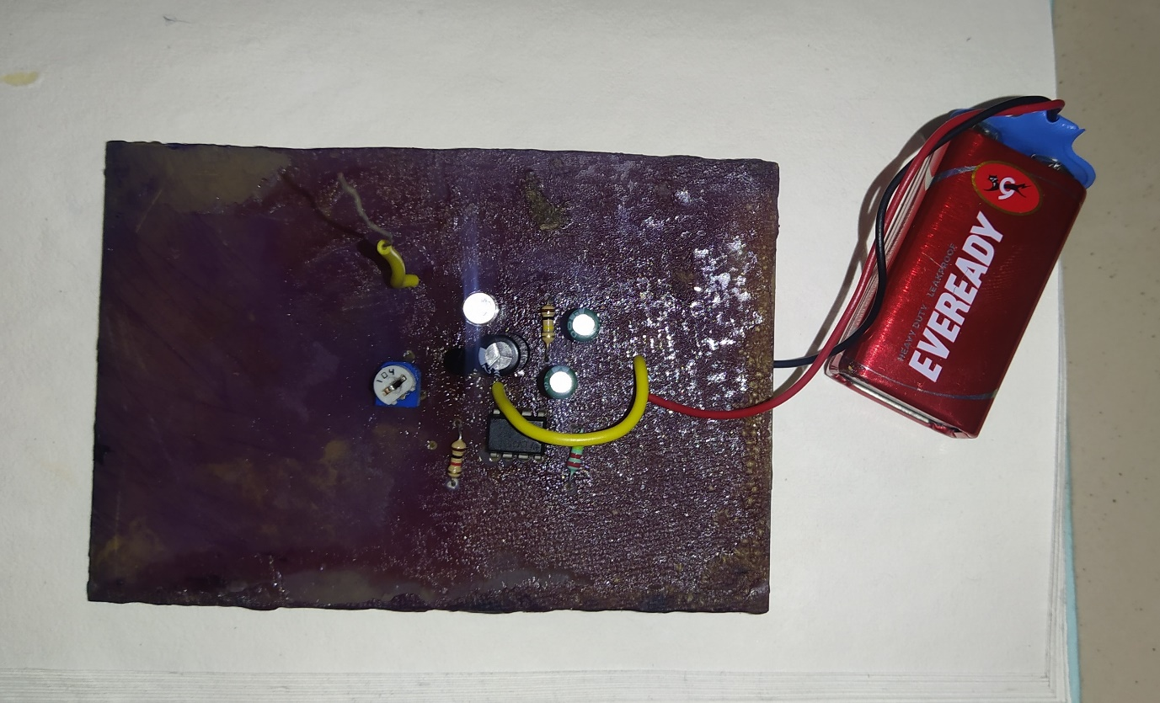

Fig 5.2.8 LED glows when mobile phone brought near

1. **TROUBLESHOOTING:**

6.1 PROBLEM/ FAULTS IN PROJECT:

1. Earlier by using the 4.5V battery, we weren’t able to get the desired output.
2. While designing the PCB, PCB packages of some devices weren’t available.

6.2 STEPS TO SOLVE PROBLEMS/ FAULTS IN PROJECT:

1. Instead of 4.5V battery, we used 9V battery using which, we get bright glowing LED.
2. We downloaded the PCB packages of components like potentiometer, resistors, etc.

**REFERENCE:**

Project idea: [Mobile Phone Detector](https://www.electronicsforu.com/electronics-projects/mobile-phone-detector-using-lm358)

PCB manufacturing process: [Toner Transfer Method](https://youtu.be/mv7Y0A9YeUc)

**DATASHEET:**

IC LM358 – 

BJT BC548 - 